

**Mission 11:**

**Remix**

**Student Workbook**





**Let’s get level!**

This assignment will let you be creative and come up with your own program for the   
CodeX to run.



Go to the Mission 11 Remix Log and fill out the Pre-Remix preparation.





**Time for a project remix**

A remix can be:

* A new program created by adding new code to a program you already created
* You can combine parts of two or more programs in a remix
* Use a similar idea in a different way

**Creating a remix will let you:**

* Master the skills and concepts practiced in the mission
* Be creative
* Remember code from earlier programs and missions
* Work with your peers
* Design an original program and write the code all on your own

**Step #1: Review the mission**

* Review your programs from Mission 3 through 11
  + What do the programs do?
  + What skills were used or concepts learned?

**DO THIS:**

* Open your project from Mission 11 -   
   Spirit Level
* Review what the program does
* Review the programming concepts and   
   skills you learned
* Fill out the information in the remix log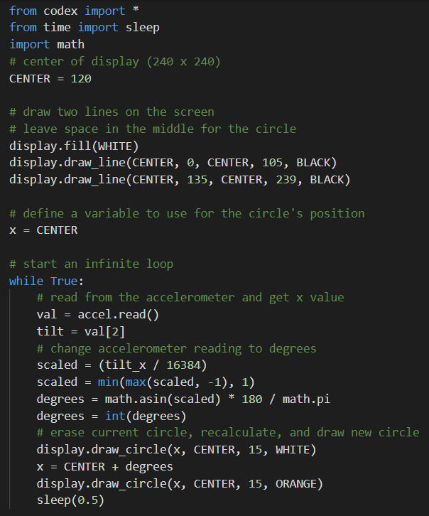

**Step #2: Brainstorm ideas**

* Read through remix suggestions.
  + Seven ideas are on the next pages. You can use any of these ideas or come up with your own.
  + You can combine any parts of the suggestions into your own mild, medium, or spicy remix.
* Use your creativity to come up with your own idea for a project.
* Decide with your partner what project you will do.



**Mild Remix #1A**

Start with the original code. Create at least one function and call it in the program. Suggestions:

* Create a function that sets up the screen and lines
* Create a function that scales the raw data to degrees

[Video of Remix #1A](https://youtu.be/vfq44gvHXg0) 

**Mild Remix #1B**

Add an introduction and wait to start the game. Add a way to exit the program using in if statement, and an ending message. The intro can be a function, but it doesn’t have to be.

[Video of Remix #1B](https://youtu.be/1vCrWLyNvGU)



**Mild Remix #1C**

Change the horizontal bubble to a vertical bubble   
(use y instead of x).

[Video of Remix #1C](https://youtu.be/TWhQNeeIx1k)



**Medium Remix #2A**

Change the circle to a filled-in circle when CodeX is level. This remix can include an intro and ending.

[Video of Remix #2A](https://youtu.be/zUyued3G_zw)



**Medium Remix #2B**

Change the spirit level to check both the horizontal and vertical positions (use both x and y).

[Video of Remix #2B](https://youtu.be/aQYERgPKaeM)



**Spicy Remix #3A**

Make the spirit level into a game. Award a point for going close to the edge but not touching the edge. Get four points to win the game. Touch an edge and the game ends.

[Video of Remix #3A](https://youtu.be/xPL-4P-aAMI)



**Spicy Remix #3B**

Change the spirit level to a spirograph. Instead of erasing the circle, let it continue to draw on the screen. Choose a random color after every 20 circles.

[Video of Remix #3B](https://youtu.be/FP7_BoUpB-M)

**Step #2: Brainstorm ideas**

**DO THIS:**

* Decide with your partner what project   
  you will do
* Fill out the information in the Mission 11  
  Remix Log for **Step #2**

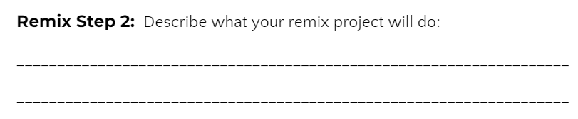

**Step #3: Make a plan**

Now that you have an idea for your remix, you need a plan.

* What variables will you need? What will you use them for?
* What functions will you create for the program?
* Do you need a list? If so, what information will it store?
* What buttons will you program, and what will each button do?

**DO THIS:**

* Fill out the information in the Mission 11 Remix Log for **Step #3**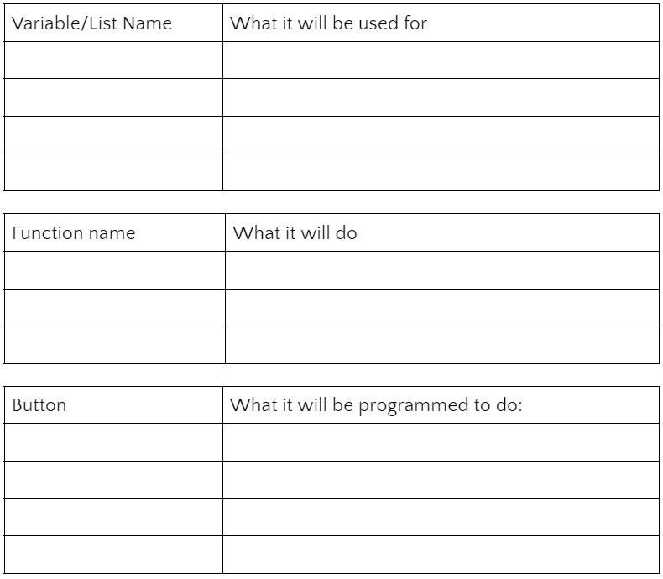

**Step #4: Code your project**

* **IMPORTANT:** In CodeSpace, go to the sandbox: 
* You can leave any program open, including **Spirit Level**, and use it as a guide



**DO THIS:**

* Start with a new file and give it a descriptive   
   name (**Remix11**)
* Import your modules
* Create your lists and functions, if needed
* Define your variables
* Write your code, testing frequently

**Reminders!**

* Don’t try to write all the code at one time
* Think about the steps –
  + Just get one thing to work, and then move on
  + Step by step!
* Mistakes happen, so find them early
* Type just a few lines of code and then run the program
* If there is an error, fix it before continuing
* Use the debugger and your other programs for help

**Step #5: Documentation**

You should always make your code readable and easy to follow.

**DO THIS:**

* + - * Add blank lines where needed to divide sections of code
      * Add a comment at the top with your name and the name of the program
      * Add a few more comments to sections of your code that explain what they do

**Step #5: Get feedback**

Getting feedback and reflecting on your code can help you make the program even better.

**DO THIS:**

* Show your code to another student
* Have him/her fill out the feedback form on your   
  Mission 11 Remix Log
* Get feedback from someone else (or yourself)
* Have him/her fill out the feedback form on your   
  Mission 11 Remix Log

**Modify your code to make your project even better**

**Congratulations!**

Now you have your own remix!   
Great job! Share your project with   
your friends.

By completing this remix you have:

* learned more about programming
* used skills and concepts from the missions
* been thinking!
* and problem solving
* and much more!
* 

**DO THIS:**

* Run projects from other   
   students
* Complete the Mission 11 Remix Log
* Don’t forget to clear your CodeX by   
   running your **Clear** program